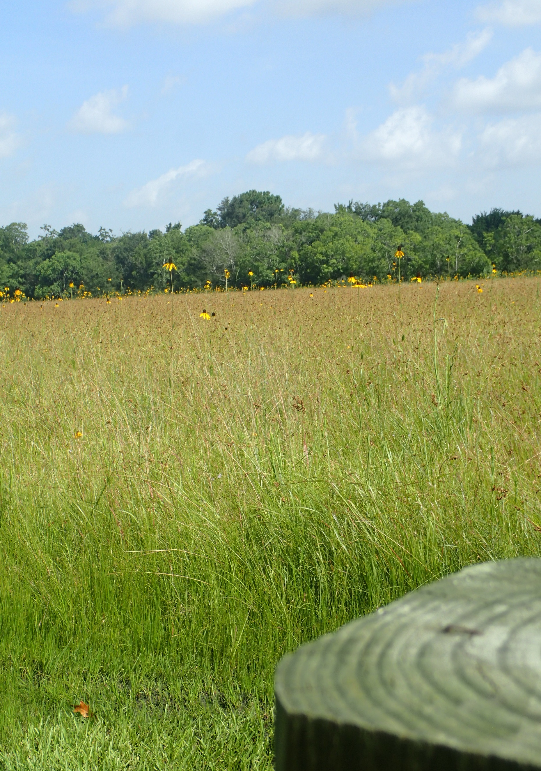

Clean Waters Initiative: Pathogen Indicators  
DRAFT AGENDA  
November 20, 2024

**A G E N D A**

|  |  |  |
| --- | --- | --- |
| 8:30 a.m. | **Sign-in and Refreshments** | |
| 9:00 a.m. | **Welcome and Event Kick-off**  **Justin Bower**  Director, Community and Environment Department – Houston-Galveston Area Council | |
| 9:05 p.m. | **Addressing Contact Recreation Impairments**  **Todd Running** Water Resources Program Manager, Community and Environment Department – Houston-Galveston Area Council | |
| 9:15 a.m. | **Presentation I**  **Jorge Santo Domingo**  Environmental Protection Agency | |
| 9:45 a.m. | **Presentation II**  **Anna Gitter, Ph.D.** Assistant Professor, Environmental and Occupational Health Sciences, University of Texas School of Public Health | |
| 10:15 a.m. | Break | |
| 10:30 a.m. | **Presentation III**  **Terry J. Gentry, Ph.D.**  Texas A&M University | |
| 11:00 a.m. | **Presentation IV**  **Michael LaMontagne, Ph.D.** Assistant Professor, College of Science and Engineering, University of Houston Clear Lake | |
| 11:30 p.m. | **Presentation V**  **Joshua A. Steel, Ph.D.** Senior Scientist, Department of Microbiology, Southern California Coastal Water Research Project | |
| 12:00 p.m. | | **Breakout Tables** |
| 12:30 p.m. | | **Wrap up and Adjourn** |