**MKT Trail to White Oak Bayou Connector via Rutland Detention Basin**

**Interagency Consultation**

.

* 9/4/18 - Meeting with Super Neighborhood representatives
  + Meeting with representatives from SN 14, SN 15 and SN 22 to discuss improvements get preliminary feedback on community concerns, as well as request letters of support.
* 7/25/208 - TxDOT – City of Houston meeting
  + Meeting to discuss improvements, get preliminary feedback, and discuss possibility of City of Houston willingness to serve as a project sponsor, if needed. The proposed project that has a north-south corridor to connect MKT to White Oak Bayou trail as well as the pedestrian and bicycle bridge over White Oak Bayou were both identified as Ped Bike connectivity Options of the Houston Bike Plan.

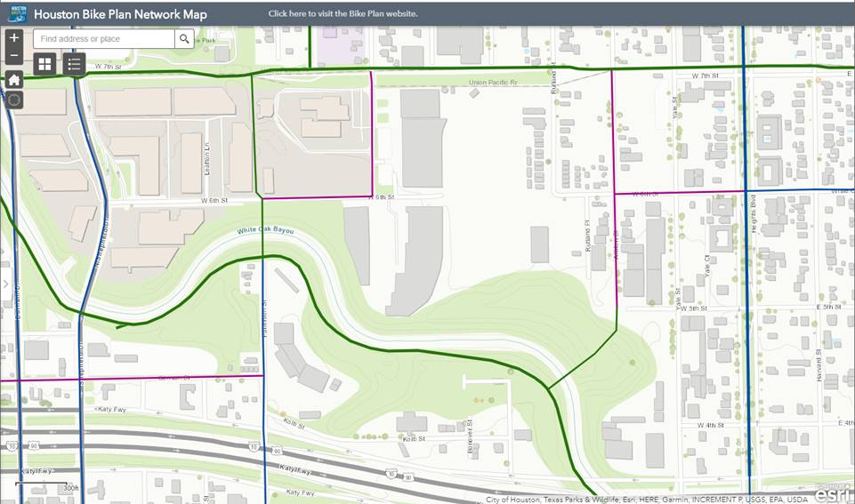

* 5/9/18 & 10/15/18 - Meeting with Houston Parks Board
  + Meeting to discuss improvements to connect to White Oak Bayou Trail as well as request letters of support.
* 9/20/18 Email correspondence between TxDOT and HCFCD regarding proposed new hike & bike trail.