Purpose:

The City’s Traffic Management Center and associated Intelligent Transportation Systems (ITS) help monitor and manage corridors, support rapid/efficient/safe traffic operations, help with incident management, and help share real-time info with motorists. This is extremely important to mobility within City which is made up of several local multilane roadways, an active railroad line, 2 state highways (US90, SH6 is a hurricane evacuation route) and one major freeway (US 59).

Currently, the existing wireless communication system has begun to fail and parts are hard to come by because it has reached end of life. The ITS Communications Rehab Project will upgrade the wireless communications equipment at 8 high sites and 65 signalized intersections which is key to mobility in this region. The below sections describe the methodology, data inputs, and estimated improvements.

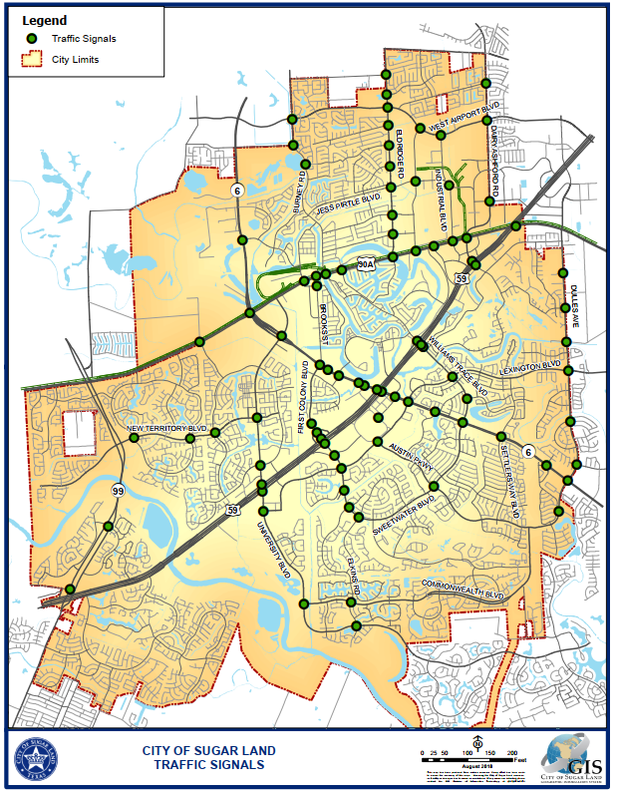

Roadway Benefit Cost Analysis:

The City chose to use the Benefits Cost Analysis (BCA) templates provided by HGAC under the roadway category instead of trying to submit 65 BCA intersection templates. The templates calculate benefits for Delay, Emissions, and Safety.

The City chose only 6 roadway segments which use all high sites needing to be replaced. These roadways are some of the most critical/busiest in the city and are listed below:

* US 90 – Eldridge Rd to US 59
* Dulles – Viking Ln to Cartwright Ave
* SH 99 – US 59 to Riverpark Dr
* Eldridge Rd (FM1876) – Florence Rd to Lakeview Dr
* University Blvd – New Territory Blvd to Elkins Rd
* Williams Trace Blvd – US 59 to SH 6

We want to emphasize that this is not a complete set of all the roadways that will benefit from this project. We chose only 6 roadways that touch different points in the City as not to double estimate benefits and to simplify the submission of application while still justifying the importance of needing to construct this project. The below map shows the six (6) roadways segments that were used for the analysis.

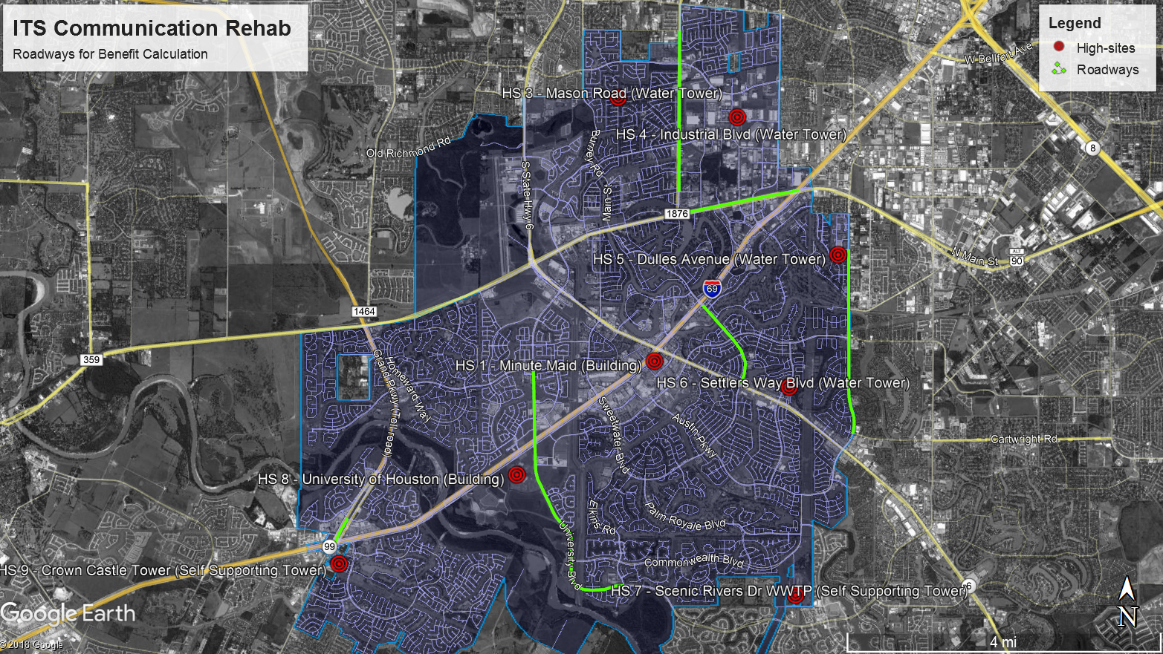

Traffic Data Inputs:

*2018 Average Daily Traffic*: The 2018 ADT counts supplied in the BCA templates are drawn from the magnetometers placed at all the major intersections throughout the City. The magnetometers are a big part of our ITS system which have shown accuracies of 95-98%. They collect turning movement counts daily, 24 hours a day.

The City chose to report the latest Tuesday (October 23, 2018) to represent the *current* 2018 average daily traffic of a typical weekday. This same data was used to also verify the peak hours needed for the templates. These volume reports are supplied in the application.

*Projected Traffic Data*: HGAC provided several data inputs which included volume counts, roadway capacity, and speed data based on their traffic demand model. A summary of provided inputs is shown below:

* Peak Period Traffic Volumes for years 2018, 2025, 2045
* 24 Hr Traffic Volumes for years 2018, 2025, 2045
* Peak Period Roadway Capacity for years 2018, 2025, 2045
* Estimated Free Flow Speeds
* Average Corridor Speeds (before improvement)

Based on the volume data provided by HGAC we calculated the growth rate from 2018 to 2025 to 2045. These rates were used in conjunction with our 2018 ADT data and peak hour data to calculate the out years (2025 & 2045). In short, the growth rates provided by HGAC via the projected traffic volumes were used with the 2018 volume data collected by the city for the fields required in the HGAC BCA spreadsheets.

Unfortunately, some locations presented a decrease in traffic volume for 2025. To overcome this limitation, we considered the yearly growth rate from the 2045 forecast and adjusted the calculation for 2025 (as can be seen in detail in the attached file, called “P1 – City of Sugar Land ITS Model Request”)

*Before and After Speed Data*: The emissions BCA sheets asks for average roadways speeds before improvements and after improvements. The average speed “Before Improvement” was provided by the H-GAC travel demand model.

For the “After Improvement” average speed the city added 5 miles an hour uniformly to all corridors. The Federal Highway Administration has several publications stating the benefits of traffic management centers, signal optimization, and adaptive systems. They document 10% to 50% improvements depending on different factors. This ITS Communications Rehab projects supports all these forms of traffic management. The city decided to conservatively use 5 mph improvement as a uniform and justified estimated improvements for all roadways with support of this project.

Results

Using the H-GAC roadway templates for Delay, Emissions, and Safety the below results were calculated for the ITS Communications Rehab project. This project is foundational to all traffic that passes through the City as ITS is deployed at every signalized intersection. The numbers show the benefits of ITS in general as they help manage traffic over large regions versus localized projects. A simple Benefit/Cost comparison shows $73,185,896 Benefit to $1,664,000 Cost.

