**Scope of Services** **Missouri City Park & Ride Long Term Lease**

The Houston Metropolitan Transit Authority of Harris County, Texas (Houston METRO) is interested in entering into a long-term capital lease (approximately 40 years) of up to 1,750 covered and structured parking spaces and related appurtenances to utilize the location as a Park & Ride facility to include bus ingress and egress, in a location that can serve growing areas of northeastern Fort Bend County.

This Request for Proposals (RFP) is seeking proposals from all parties who are ready, willing, and able to provide METRO with a long-term capital lease for a Park and Ride facility with covered and structured parking spaces and related appurtenances to include bus ingress and egress, that the proposer owns, will acquire, or designs and develops on real property that it already owns or will acquire in an area located near the intersection of the Fort Bend Parkway Toll Road and State Highway 6. (See Figure 1). The facility must be available and operationally ready for METRO use no later than January 31, 2024. METRO will consider proposals which slightly deviate from the geographic boundaries described above and in Figure 1 so long as the proposer can demonstrate that the proposed location will appropriately serve the public transportation needs of the area.

Figure

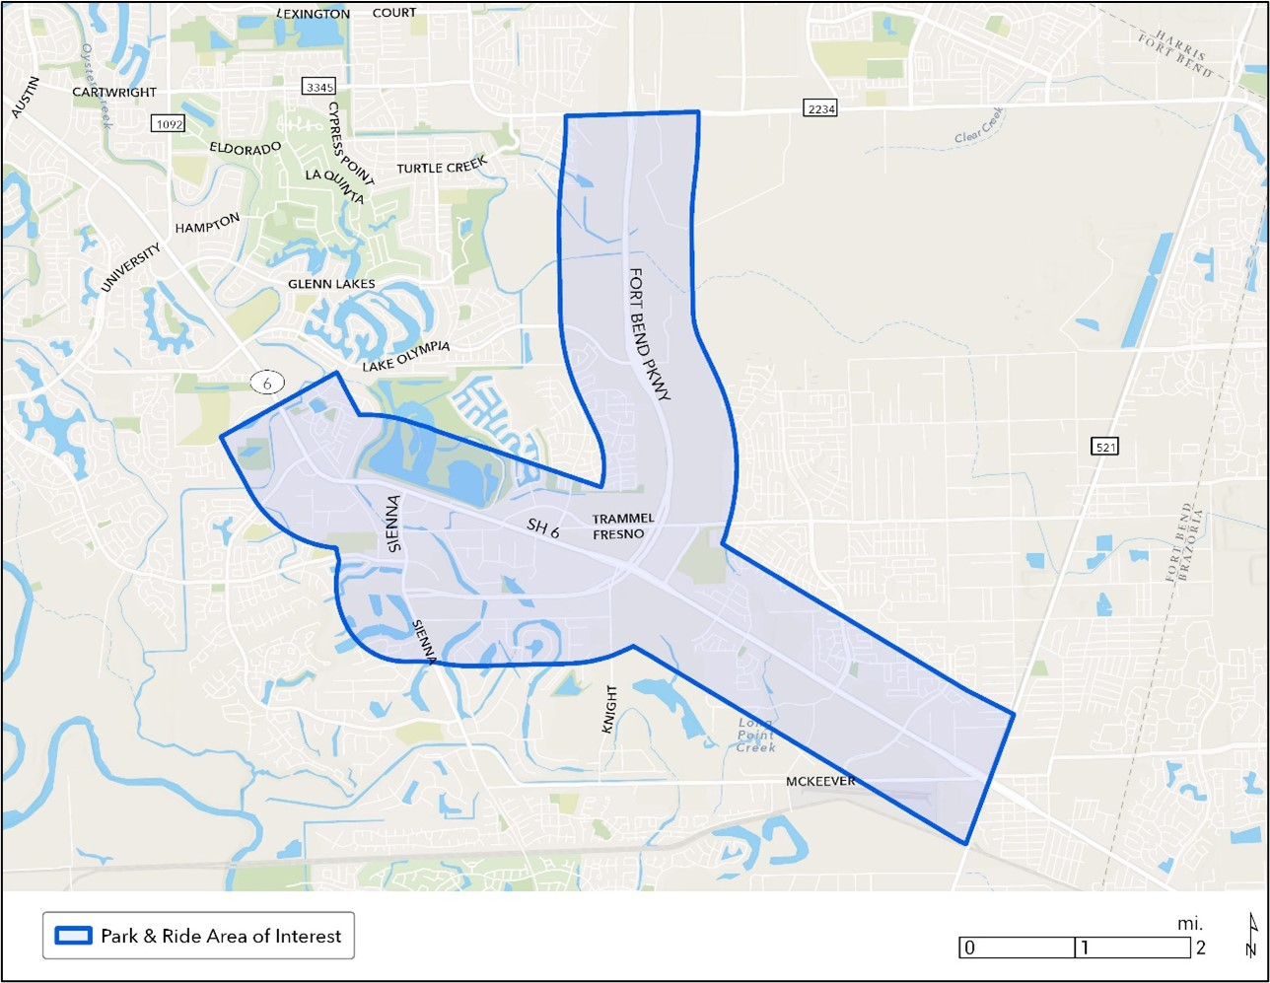

RELEVANT GOALS OF THE PROJECT:

* Increase transit ridership through the coordinated planning of land use and development of properties on and near METRORail stations, Transit Centers, Park & Rides or other facilities, reducing automobile use and congestion for the benefit of the environment;
* Enhance the value of METRO assets by locating and designing transit facilities to accommodate both existing and future TOD uses;
* Support a mix of uses that will encourage transit use throughout the day and meet identified needs of transit riders and the immediate area;
* Provide pedestrian oriented development and create a sense of place around a transit facility that is compatible with the nature, scale and aesthetics of the surrounding community;
* Consider local interests in the location, design, function and operation of the transit oriented development to the extent reasonable and appropriate;
* Promote the highest levels of quality in terms of urban and architectural design; and
* Generate economic development benefits through job creation and additional revenue for the local economy.

SPECIFICATIONS:

1. The facility shall include up 1,750 vehicular parking spaces with parking geometrics and an accommodation for restrooms, passenger waiting, etc., consistent with existing METRO structured and covered park and ride facilities.
2. The facility shall have a useful life, based on its structural integrity and its overall state of good repair, of at least 50 years from January 31, 2024.
3. The facility will be used by METRO as a park and ride facility. METRO will require access, ingress, and egress to the facility and its grounds for 24 hours a day to satisfy this use. The proposed facility should provide good overall accessibility for buses, patrons.
4. The facility / lot must be Americans with Disabilities Act (ADA) compliant and Texas Department of Licensing and Regulations (TDLR) compliant. The facility must accommodate accessible, efficient, and safe flow of passengers from the parking area to a bus circulation area. In addition, the use of the facility should be electronically monitored in terms of vacant space availability.
5. The bus circulation area, and related roadway ingress and egress must accommodate METRO transit buses which have approximate dimensions of 40-FT length, 9-FT width, and 13-FT height.
6. The facility shall provide accessible restrooms for the transit patrons.
7. The facility shall accommodate passenger safety and security features such as lighting.
8. The facility should be visible and easily accessible from the surrounding roadway network, and provide efficient vehicular access. The facility must accommodate interior and exterior branded METRO signage in the price proposal as a component of the lease agreement.
9. The facility shall accommodate Park and Ride patrons utilizing gate equipment for the purposes of rider validation and payment. This equipment must be included in the price proposal as a component of the lease agreement.
10. The facility conveyed to METRO, in exchange for the lump sum up-front capital lease payment, will at a minimum include the items identified within this request for proposals, and include a Certificate of Occupancy, or if built, contingent on Metro inspection in terms of federal standards. Additional items may be requested and negotiated during contracting.
11. METRO will be responsible for all utility payments for the garage and will repair, operate, and maintain the facility at a standard equal to the standard of repair and maintenance for other comparable METRO transit facilities. METRO, at its expense, will be responsible for additional improvements and modifications to the facility beyond those agreed upon within the initial lease contract.
12. Any parking rates or fares charged are at the sole discretion of METRO and shall be retained by METRO.
13. The project must be constructed using materials as consistent with FTA Buy America requirements.
14. The project must comply with or otherwise address all National Environmental Policy Act (NEPA) requirements as identified by METRO and/or the Federal Transit Administration. METRO is responsible for NEPA clearance.
15. If the facility is in design, not yet designed, or requires modification to meet the specifications identified for the facility as described by the proposer, METRO will require prior review, comment, and approval on engineering plans and specifications. Facility must be designed to METRO standards.
16. METRO will consider the incidental use of the garage for non-transit purposes by the lessor, to the extent it does not limit or otherwise restrict the transit use.
17. The proposed agreement for the facility itself (parking garage, associated passenger waiting area, etc.) is for approximately 40 years and will be paid for lump sum, up-front as a capital lease.

Proposers are encouraged to identify other project components which would ensure a successful facility. All elements can be included within the proposal and incorporated into the price proposal accordingly.