Metropolitan Transit Authority of Harris County

SCOPE OF WORK (SOW)

**Replacement Northline Transit Center Construction Project**

# General Project Description:

# The Project shall consist of providing all supplies, support services, data, labor, tools, materials, equipment, supervision, construction and all else required to prepare the site and construct the Replacement Northline Transit Center project which is generally located near the Northern terminus of the METRO’s North Corridor Light Rail Transit Line near Northline Commons Shopping Center (formerly Northline Mall). It is situated on the northeast corner of Fulton Ave. and Rebecca St.

# Existing Conditions:

# The existing Northline Transit Center facility has been existence since 2001 with the property under the ownership of Northline Joint Ventures. The lease for the Northline Transit Center is set to expire in 2021, and in order to meet the demand of METRO customers and provide adequate parking, it has become imperative to explore opportunities for the construction of a new transit center. Currently, this facility serves 7 routes with an average weekly ridership of 3,094 boardings. The proposed Northline Transit Center would replace the existing transit center, which accommodates transfers for local bus service, and allows for seamless connections to other parts of METRO’s service area and beyond. The site is currently a contains a mix of unoccupied residential, retail and storage structures.

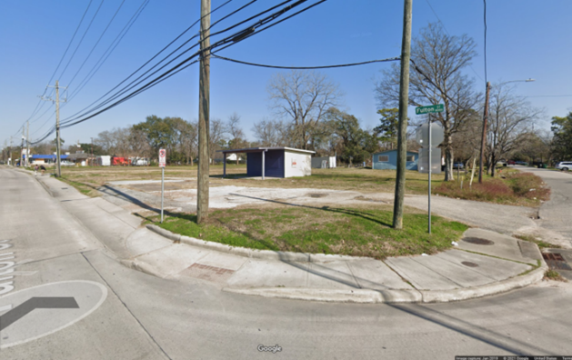

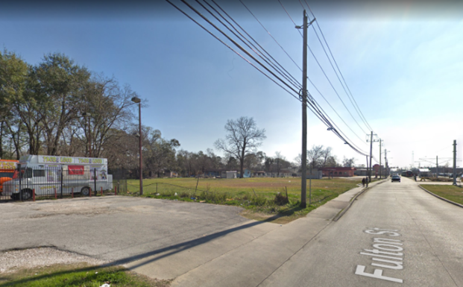

**The major scope of work elements consists of, but not limited to:**

The major scope of work elements listed below are to provide a summary of the major work elements. Please refer to the construction plans and technical specifications for detailed scope items. Contractor to provide a fully functional transit center and other plan set elements, regardless of minor missing details. Contractor is required to do a quantity take off at bid time and consider such quantities in bid. Bid is to be lump sum.

Contract award will be based on the Stipulated Price (Lump Sum) included in the Proposal. Schedule of Values (SOV) completed sheets are required and unit prices will only be used to evaluate the reasonableness of the Stipulated Price and to serve as a basis of progress payments during construction. A SOV submitted with an apparent mathematically or materially unbalanced unit pricing may be grounds for rejection of the proposal if it serves METRO's interests to do so or protects the integrity of the competitive sealed bidding system.

1. Provide administration and construction support services as a contractor to complete work.
2. Coordination with third parties such as utility owners, governing agencies, and other contractors who may work in the vicinity of the project site.
3. Clear and grub the area of vegetation, shrubs, debris and existing trees and bushes not designated to remain.
4. Ensure the protection of trees, shrubs, vegetation, structures, and facilities where indicated.
5. Perform demolition and removal of above ground and underground structures and facilities as outlined in the Bid Documents.
6. Perform required earthwork, including excavation, embankment, backfill and compaction. If any fill or backfill material is needed, and onsite material doesn’t meet specifications, the contractor shall supply suitable material per the Technical Specifications.
7. Perform soil stabilization as required for paving.
8. Construct the five (5) story transit center as indicated in plans.
9. Contractor may propose a voluntary alternate to use precast instead of cast in place options, and if exercised, the contractor is to submit proposal pricing in detail within their proposal submittal. If awarded and approved, contractor would be required to produce any related engineered drawings and subsequent shop drawings and permitting.
10. Contractor may propose a voluntary alternate to use an alternative foundation system such as geopiers instead of the spread footings currently shown in the design, and if exercised, the contractor is to submit proposal pricing in detail within their proposal submittal. If awarded and approved, contractor would be required to produce any related engineered drawings and subsequent shop drawings and permitting
11. Construct bus and vehicle traffic roadways, curbs, walks, ramps, shelters, and parking area columns, foundations, pads, and building, as indicated in the design documents
12. Construct storm and sanitary sewer systems and appurtenant structures.
13. Construct water and irrigation lines and appurtenant structures.
14. Provide fencing and gates as indicated.
15. Provide landscaping, including seeding, sodding, and planting and maintenance.
16. Provide pavement markings, traffic and parking signs and traffic signals as indicated.
17. Provide lighting, lightning protection, public telephone and electrical facilities and systems.
18. Provide a clean Site during the Work and prior to written acceptance by METRO. Contractor to meet noise and dust control requirements.
19. Per plan, extend offsite drainage, water, and sanitary sewer facilities to the site.
20. Provide traffic control as indicated during construction.
21. All proposed construction related items should be “BUY AMERICA” compliant. If an item specified is found not to be “BUY AMERICA” compliant, contractor shall notify METRO. Contractor will be responsible for bidding and executing the work with Buy America compliant products. Contractor to state in proposal who will be their Buy America point of contact.
22. Contractor shall not perform any change order work unless a change order has been signed or METRO has directed the work in writing via force account.
23. All bidders will be required to initiate their own quantity take-off.
24. A METRO PM will review and approve the shop drawings before work starts. Contractor will submit a submission and review schedule for all submittals to the owner, consistent with the Project Schedule.
25. Contractor to submit work plans for public utility work, subgrade work, paving work, foundations, structural concrete work (slabs, columns/caps, etc.), steel erection, MEP and finishes will need to be accepted by METRO construction department prior to these work activities beginning.
26. Contractor to hand dig when within 2 feet of any existing utility and will be responsible for damages to any existing utilities.
27. Securing all required permits from jurisdictions having authority (i.e. – METRO, City of Houston, TCEQ),
28. Contractor will appoint a Full-time Contractor Quality Manager for this project. Contractors Quality Plan will be submitted at least two weeks prior to work starting and will explain what measures the contractor will take to ensure compliant work is produced.
29. Per Spec Section 01451-5, the Contractor shall perform inspections, tests and other services to ensure that all work conforms to Contact requirements. Where required by the specifications to conduct such testing, the Contractor shall request the services of an independent testing laboratory employed and paid for by METRO
30. As part of the improvements to the Fulton ROW, Contractor shall provide an allowance for the improvements to the Northline METRORail Station to facilitate installation of the mid-block pedestrian crossing and signal.

**Basic Requirements / Special Conditions:**

1. The Work shall comply with the requirements of the Contract Documents including cited national specifications and standards, state and local government authority codes, regulation, and specifications.
2. In case of conflicts or discrepancies between cited national and local standards, local requirements shall govern unless otherwise directed in writing. In case of conflicts or discrepancies between institutional, national, and federal specifications as referenced for inclusion with a METRO standard specification, the most stringent of the specifications listed shall govern unless otherwise directed in writing by the owner. All conflicts shall be brought to the attention of METRO in writing for resolution as soon as the contractor is aware such conflict exists.
3. The Contractor shall review, field verify, and confirm all existing conditions (to include but not limited to stated dimensions, drawings, layouts, etc.) prior to performing this work. The Contractor shall also comply with all applicable Specifications as stated in the bid specification book.

1. The Contractor shall submit manufacturer and material specifications/submittals, detailed P6 construction schedule, Contractor Safety Management Plan, Contractor Quality Control Plan, and phasing plans to METRO’s Project Manager for review and approval prior to beginning of the work.
2. P6 Construction schedule and monthly pay estimate are required to be submitted no later than the 5th of each month for work done in prior month.
3. The Contractor is to coordinate with METRO’s Project Manager for construction vehicle access and related personnel activities within the facility.
4. The Contractor shall comply with all METRO and OSHA safety requirements and shall be fully responsible for all occurrence or accidents due to his work.
5. The Contractor shall coordinate his work to minimize disruptions to METRO’s operations and as directed by METRO. The normal hours of operation are 7:00 am to 5:00 pm (Monday thru Friday). Any necessary after hour / weekend work shall be scheduled with Project Manager 48 hours in advance.
6. The Bid Documents have the engineer’s sealed set of plans & specs (attached as separate bid documents).
7. It will be the responsibility of the selected Contractor to schedule necessary city inspections and permit closeout including obtaining the occupancy certificate from the permitting authority and ensure a fully functional system that communicates with METRO and COH accordingly.
8. The Contractor shall safely haul and legally dispose of all removed material from the site and follow all safety and environmental codes and regulatory requirements for this work
9. Space will be assigned to the Contractor for staging and placing of equipment during the construction. The Contractor shall barricade and secure this area and maintain it in a neat, clean, and orderly fashion.
10. A daily sweeping and cleaning initiative will be required to keep the facility and adjacent roads at entrances being utilized in an operable condition. Construction entrances will need to be turned/refreshed as needed by contractor and will only be paid at the initial install.
11. Pumping of water on site or in trenches will not be paid and must be done through a filter sock. Contractor to supply/service portable rest rooms for construction crews.
12. Prior to bidding, The Contractor shall visit the facility, review, and verify each site field condition. METRO highly recommends that the Contractor attends the original site visit to be scheduled. METRO will arrange an alternate site visit if requested by the Contractor in writing.
13. All work should comply with the requirements of this document including all national specification and standards, NFPA 70, NEC, COH building, plumbing, electrical, mechanical and fire codes, state and local government authority codes, regulations, and specifications.
14. The Contractor will be required to conduct weekly progress meetings with all relevant METRO departments including construction, safety, facilities maintenance, and operations personnel. These meetings will consist of a safety review and a three week look ahead schedule for progress. The contractor will be responsible for distributing progress meeting minutes to METRO personnel. Contractor required to submit daily look ahead schedules.
15. The Contractor shall provide a site security containment system as required, around the perimeter of the work. The containment system must be enough in size and nature to ensure personnel safety.
16. The Contractor will be held responsible for any damages associated with the work performed.
17. Contractor will supply the METRO Project Manager with all O&M Manuals, any training recommended by the manufacturer of elevator or fire alarm systems and a written Preventative Maintenance Program.
18. Upon the completion of the project the Contractor will submit a written letter of warranty to the METRO Project Manager. Warranty period of performance for workmanship must be a minimum of 12 months from the date of final acceptance.
19. The Contractor shall produce and keep current redline and as-built drawings both in electronic version and hard copy.
20. Contractor is responsible for Testing, Commissioning and Handover of all equipment and facilities in this contract.
21. The overall period of performance consisting of 5 (five) phases of construction for the project is up to 1,054 calendar days from the issuance of the Notice to Proceed (NTP).
22. If there are security related issues during construction, the contractor is to file a report immediately to METRO Police @ 713-224- COPS
23. METRO will pay the permit fee at cost. Include pricing in the bid.
24. METRO will pay for bonds (bid/payment & performance) at cost. Include pricing in the bid.
25. Contractor to provide a functional/furnished double wide trailer for METRO and consultant staff, including new high speed color printer/scanner/copier, high speed internet/Wi-Fi, 4 furnished offices, and a conference room with large conference table and chairs. Contractor at minimum shall provide a double wide trailer for their office staff, at same quality furnishings as for METRO. Contractor to coordinate location of field office onsite or offsite with METRO Project Manager. If the field office is offsite, it must be within a mile of the project location and is to be paid for by the contractor.
26. Contractor to provide a BIM model for the transit center, updated throughout construction, which includes MEP details.
27. If prestressing or post tensioning concrete construction methods are used, contractor to provide qualified inspector to observe the subject operations and keep log of jacking forces, elongations, etc., and submit certified records to the engineer of record.