**Port of Houston Authority Barbours Cut Terminal Container Yard 7**

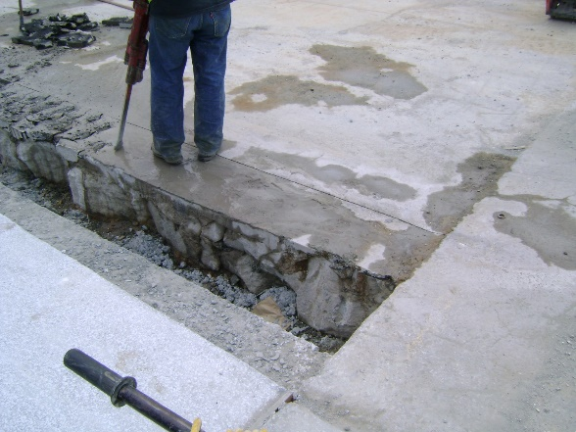***Barbours Cut Container Terminal at the Port of Houston Authority is part of a major national gateway for trade and a strategic economic asset for the State of Texas, which is experiencing some of the fastest growth in trade in the nation. This freight project will provide: significant economic benefits for the nation, state, and region; operational efficiencies and enhanced connectivity for multimodal transportation; safety improvements; and environmental benefits. The total estimated cost of the project is $53,300,000 enabled by federal funds of $12,967,634, with a local cost share of $40,332,366. The Port is requesting TxDOT’s support for the $40,332,366. Initial costs have increased due to inflation.***

The Port of Houston Authority’s (“Port Authority”) Barbours Cut Terminal, a premier intermodal facility on the U.S. Gulf Coast, was designed to optimize productivity by providing a fast turnaround for container and cargo vessels. The original terminal design was not intended to process the amount or weight of the freight currently being handled. Container operations have evolved from chassis mounted containers to densified stacks. This has increased truck turn times and caused safety concerns as parts of the yards are taken out of service due to disrepair and required upgrades. Restoration and upgrade are needed to handle the current and future demand of cargo calling at Barbours Cut Terminal.

**This project merits approval for a grant award because it demonstrates:**

Economic Impact: Port Authority-related businesses contribute 1,350,695 jobs throughout Texas, up from 1,174,567 million jobs cited in a 2014 study. The Port Authority is an economic engine for the nation, state, and region. Activity at the Port Authority sustains 3 million U.S. jobs, provides $802 billion in economic value, and generates $38 billion in federal, state, and local tax revenue. The Port Authority is a critical resource that produces jobs and economic prosperity for the state and local economy. Throughout its history, whenever the Port Authority has thrived, the Houston area has thrived. The project supports the community of clients who ship to and from the Port Authority’s container terminals. Operational Impact: Reduction of truck turn time by streamlining and maintaining a state of good repair for 29 acres of yard space results in $199,967,297 in efficiency benefits.

* Enhances Connectivity: The container yard connects the water side and roadside of the State’s multimodal transportation system.
* Safety and Security: This project will improve the Port’s resiliency by reconstructing the container yard which was initially constructed between 1975 and 1985. Cargo crossing the terminal is already reduced due to its weight limits to ensure the movement is safe for customers and employees.
* Other: Reduction of emissions by reducing turn times for processing containers totals $64,124,975 in undiscounted benefits.

This includes 8,994,803 short tons of CO2.