GELLHORN & OATES

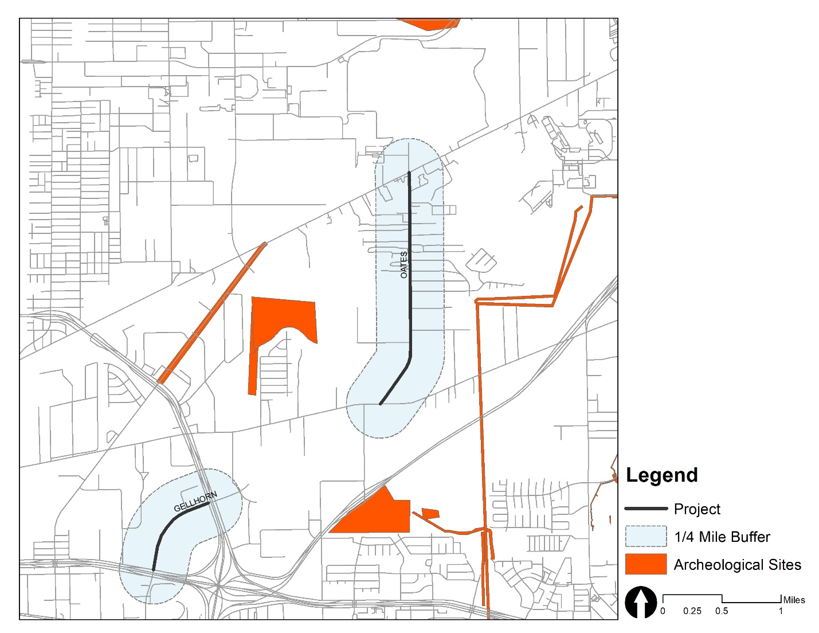

* Type: survey
* Date: 5/12/2010
* Sponsor Agency: Texas Parks and Wildlife Department, City of Houston
* Investing Firm: Moore Archeological Consulting
* Project Proponent: White Oak Studio Landscape Architecture